**Assignment-6**

**1. C program to count the total number of words in a string.**

CODE

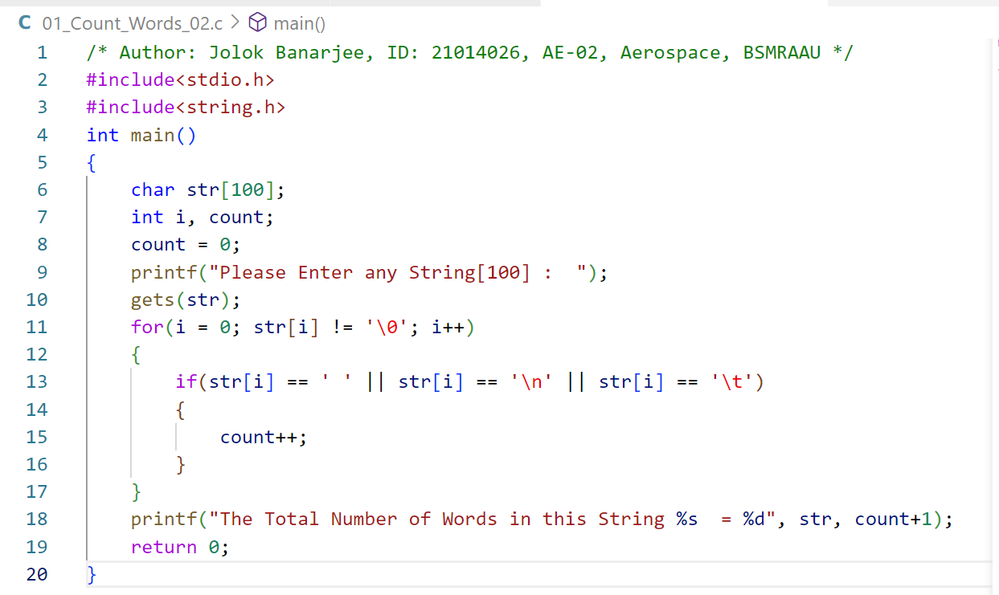

OUTPUT

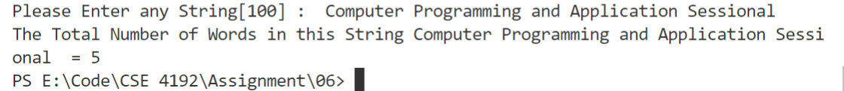

**2. C program to sort a string in alphabetical order by swapping the characters in the string.**

Enter the string : face

The sorted string is : acef

CODE

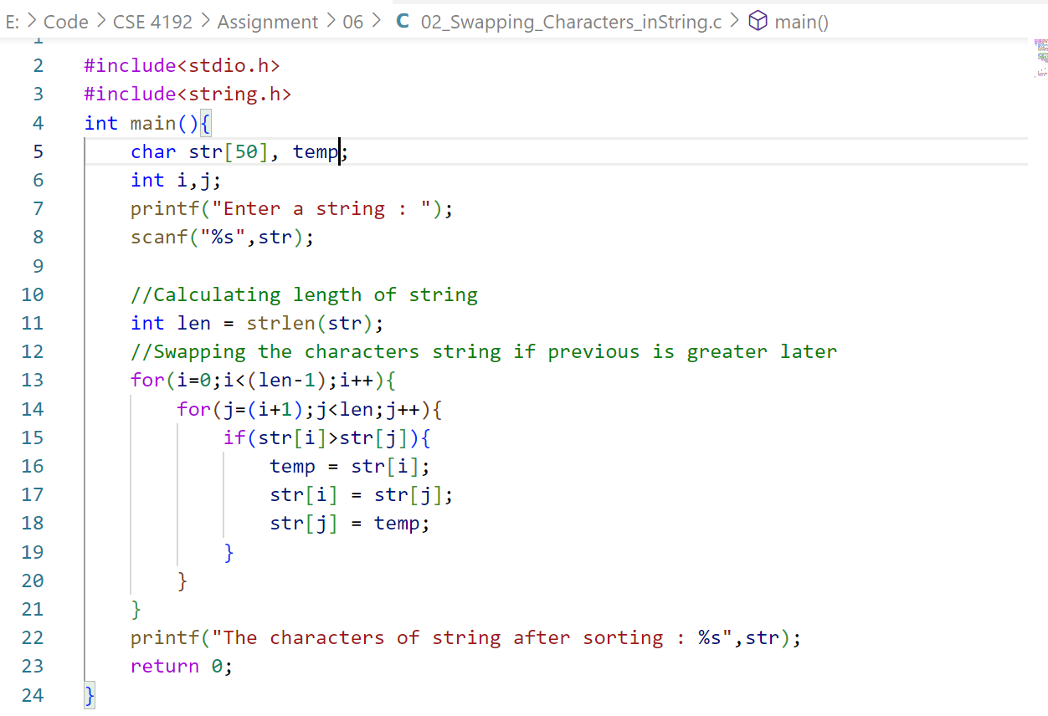

OUTPUT



**3. C program to extract a substring from a given string.**

Input the string: This is test string

Input the position to start extraction : 9

Input the length of substring : 4

The substring retrieve from the string is: " test "

CODE

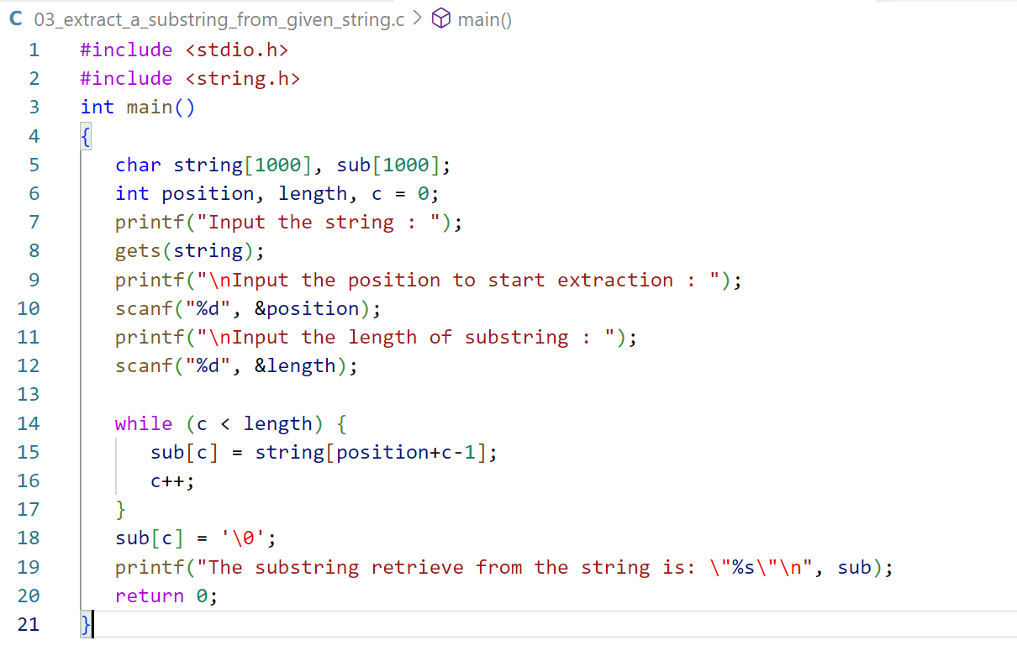

OUTPUT

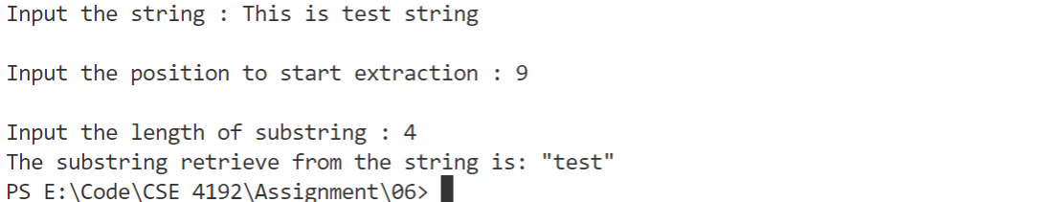

**Lab Work-6**

**1. Write a program in c to check two string equal or not.**

CODE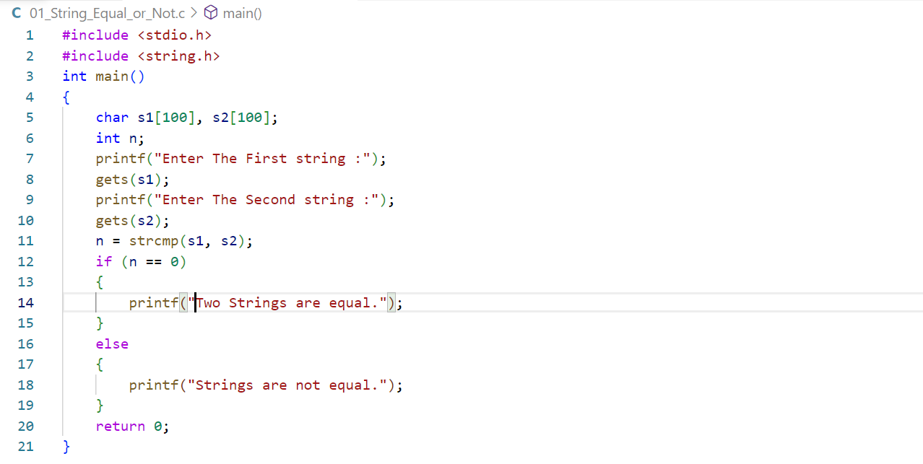

OUTPUT 1



OUTPUT 2

**2. Write a program in c merge in two string.**

CODE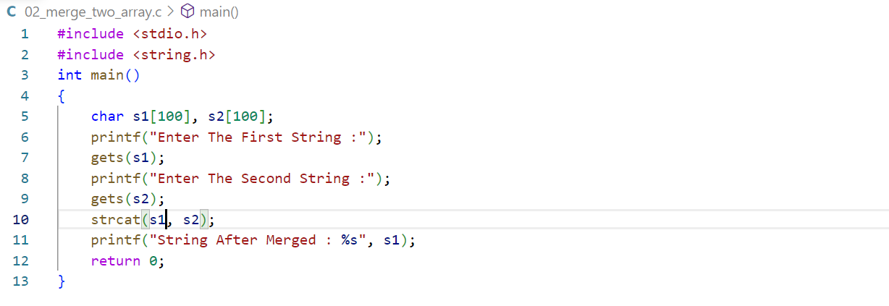

OUTPUT



**3. Write a program in c to check vowel and consonent of a string.**

CODE

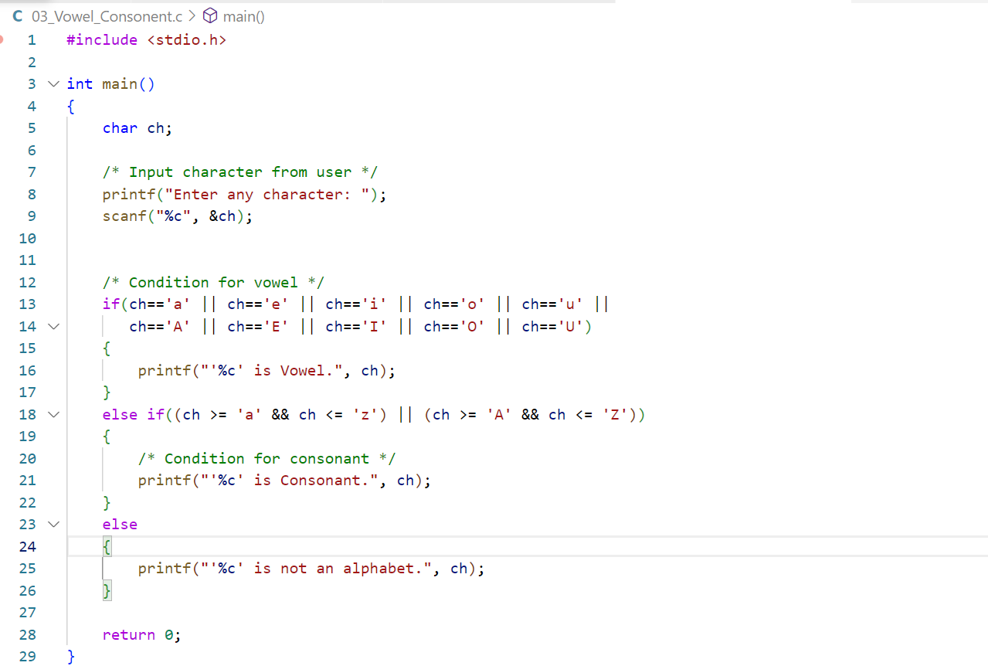

OUTPUT

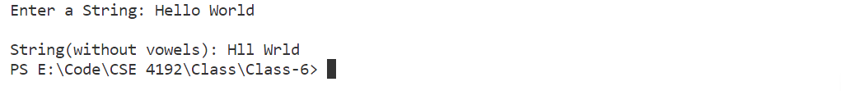

**4.Write a c program to finds its frequency of a string.**

CODE

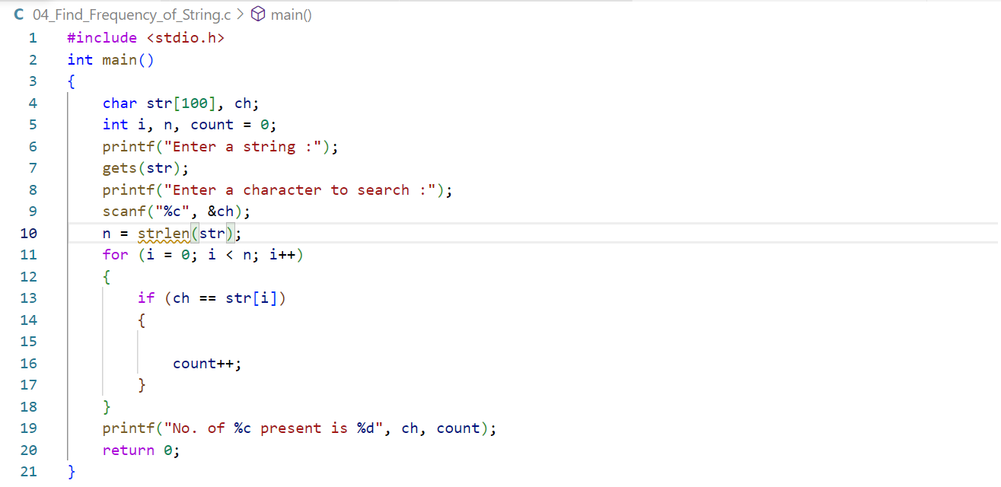

OUTPUT

